** NAME:Aryaman Mishra**

**REG. NUMBER: 19BCE1027**

**EXPERIMENT NO.5**

**DATE: 27-3-22**

**PSYCHOLOGY LAB RECORD BOOK FORMAT**

* **TITLE OF THE EXPERIMENT**

**Creativity and Problem-Solving**

* **AIM:**

Test problem solving and creativity skills at individual and group level.

* **MATERIALS REQUIRED:**

Links:-

<https://psychologytoday.tests.psychtests.com/bin/transfer>

<https://www.kellogg.northwestern.edu/faculty/uzzi/ftp/page176.html>

* **DESCRIPTION OF TEST:**

Creativity is linked to fundamental qualities of thinking, such as flexibility and tolerance of ambiguity. This Creative Problem-solving Test was developed to evaluate whether your attitude towards problem-solving and the manner in which you approach a problem are conducive to creative thinking.

The Psychology Today test is made up of two types of questions: scenarios and self-assessment. For each scenario, answer according to how you would most likely behave in a similar situation. For the self-assessment questions, indicate the degree to which the given statements apply to you. In order to receive the most accurate results, please answer each question as honestly as possible.

The Kellog test helps you determine if you have the personality traits, attitudes, values, motivations, and interests that characterize creativity. It is based on several years' study of attributes possessed by men and women in a variety of fields and occupations who think and act creatively.

* **PROCEDURE**

**Fill in the options given ahead of the questions and compute scores in order to describe your problem solving and creativity level.**

* **TABLE 1:**

**INDIVIDUAL DISCUSSION**

Problem solving occurs when you try to remove an obstacle that is blocking a path you want to take or when you try to close the gap between what exists and what you want to exist. Decision making takes place after you encounter a problem. It refers to selecting one alternative from the various courses of action that can be pursued.

Many traits and characteristics influence the type of problem solver you are now or are capable of becoming. Among them are (1) cognitive intelligence, education, and experience; (2) emotional intelligence; (3) flexibility versus rigidity; (4) intuition; (5) concentration; (6) decisiveness and perfectionism; (7) risk taking and thrill seeking; and (8) values.

The Myers-Briggs Type Indicator is a widely used method of classifying problem-solving styles. Four dimensions of psychological functioning underlie the method: introverted versus extroverted; thinking versus feeling; sensing versus intuiting; and judging versus perceiving. Combining the four types with each other results in 16 personality types, such as a person being a conceptualizer, traditionalist, visionary, or organizer. For example, the organizer (ESTJ) scores high on extroversion, sensing, thinking, and judging. Recognizing your problem-solving style can help you identify work that you are likely to perform well, such as those mentioned in Exhibit 3-1.

The decision-making process outlined in this chapter uses both the scientific method and intuition for making decisions in response to problems. Decision making follows an orderly flow of events:

1. You are aware of a problem or create one of your own.  
2. You identify causes of the problem.  
3. You find creative alternatives.  
4. You weigh the alternatives.  
5. You make the choice.  
6. You implement the choice.  
7. You evaluate whether you have made a sound choice. If your choice was unsound, you are faced with a new problem, and the cycle repeats itself.

Creativity is the ability to look for good ideas that can be put into action. Adaptive creativity involves improving an existing system, whereas innovative creativity involves creating something new. Creative workers tend to have different intellectual and personality characteristics than their less creative counterparts. In general, creative people are more mentally flexible than others, which allows them to overcome the traditional way of looking at problems.

Creative thinking requires a broad background of information, including facts and observations. Creative workers tend to be bright rather than brilliant. The key to creative intelligence is insight. Creativity can stem from both fluid (raw) intelligence and crystallized (accumulated) intelligence. The emotional and other nonintellectual aspects of a person heavily influence creative problem solving. For example, creative people are frequently nonconformists and thrill seekers.

Creativity takes place when three components come together: expertise, creative thinking skills, and the right type of motivation. Creative thinking refers to being flexible and imaginative. The right type of motivation refers to passion for the task and intrinsic motivation. Four factors outside the person play a key role in fostering creativity. An environmental need, enough conflict and tension to put people on edge, encouragement from management, and the presence of humor. Unless a person is working on a highly focused task, time pressures are likely to diminish creativity.

Methods of improving your creativity include (1) concentrating intensely on the task at hand; (2) overcoming traditional mental sets; (3) disciplining yourself to think laterally; (4) conducting brainstorming sessions; (5) borrowing creative ideas; (6) challenging your ruts; (7) establishing idea quotas; (8) playing the roles of explorer, artist, judge, and lawyer; and (9) taking a break.

Brainstorming has several variations, including electronic brainstorming in which people enter ideas into a computer. Brainwriting is essentially solo brainstorming. The forced-association technique requires problem solving by making associations between the properties of two objects.

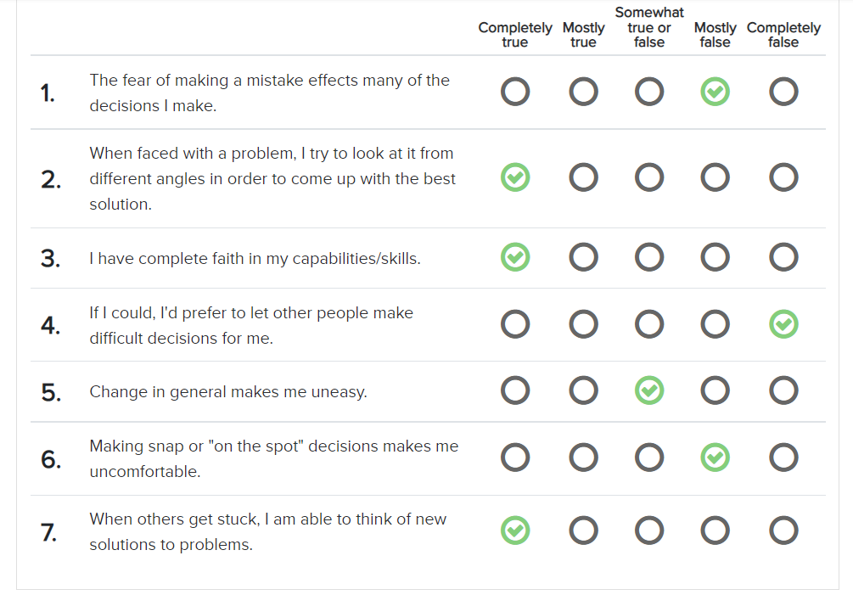

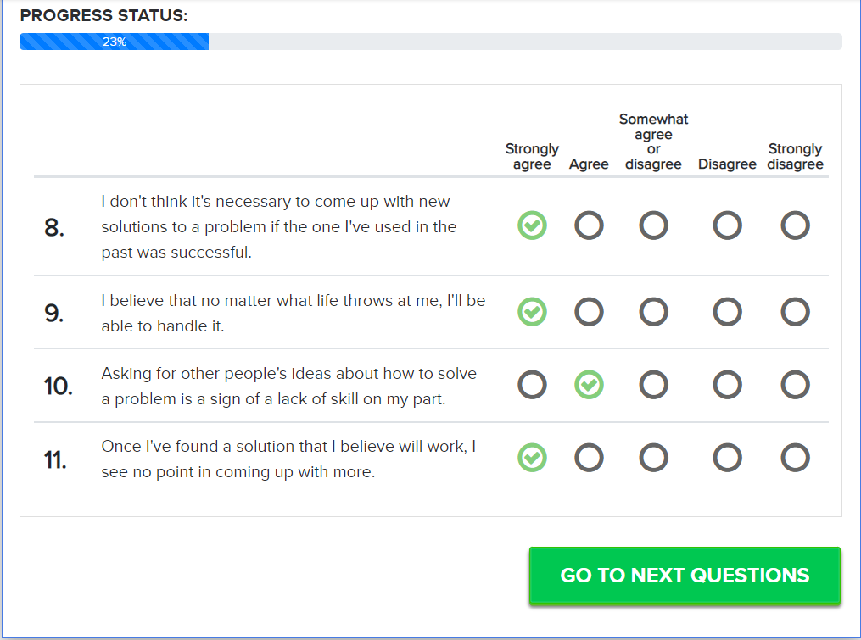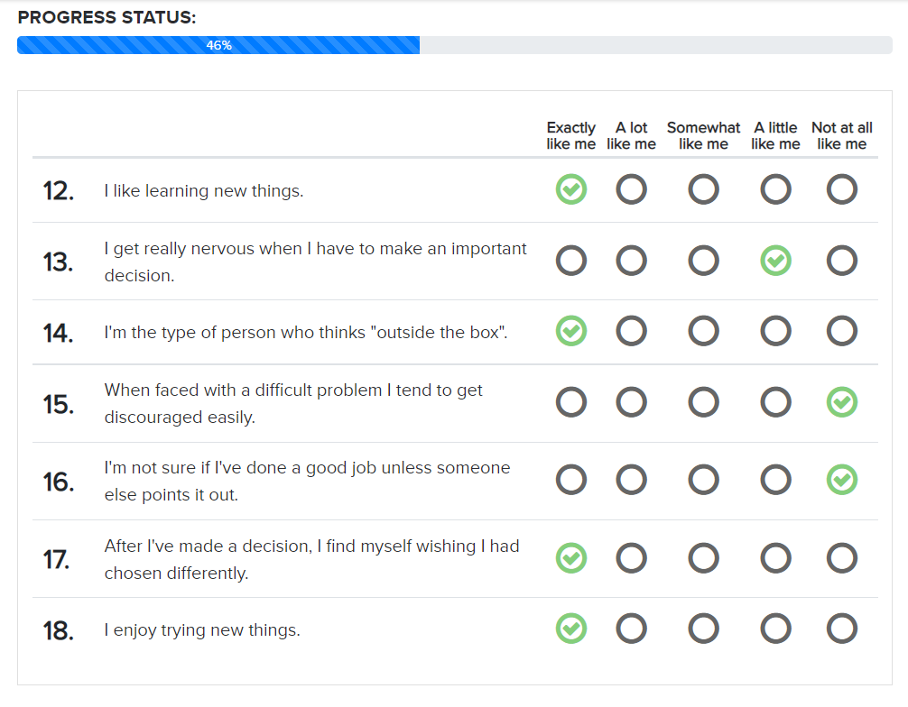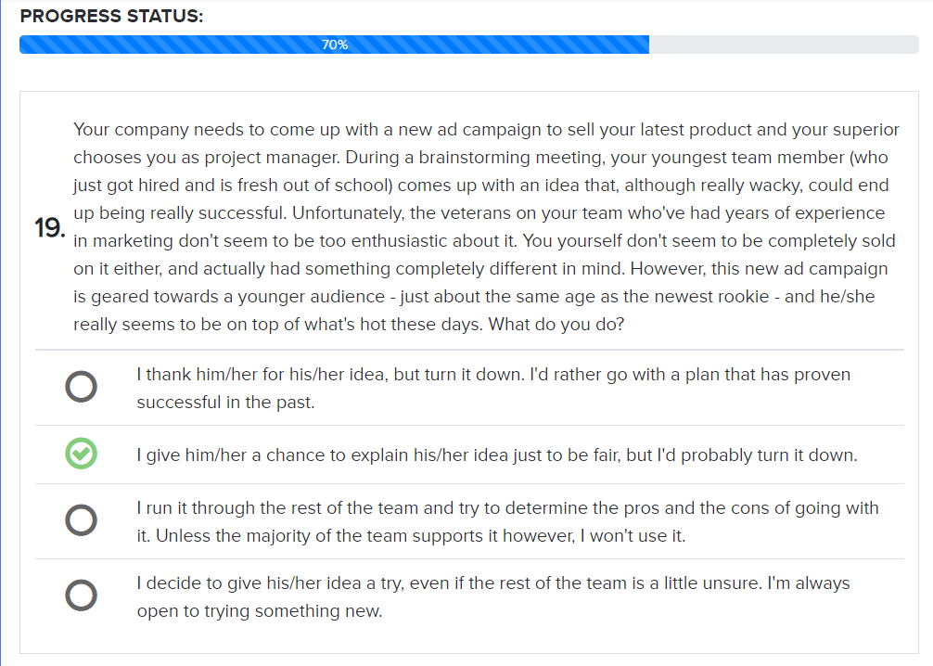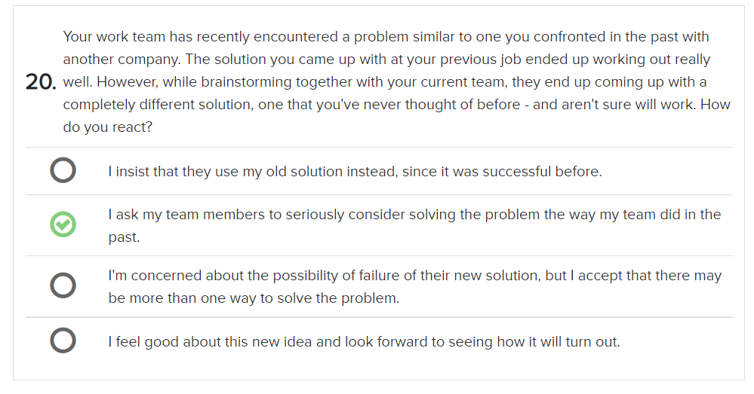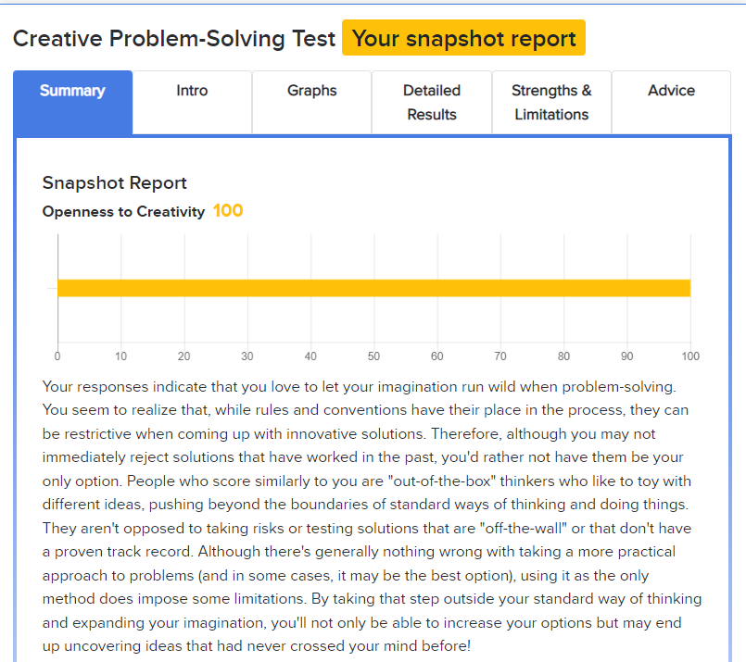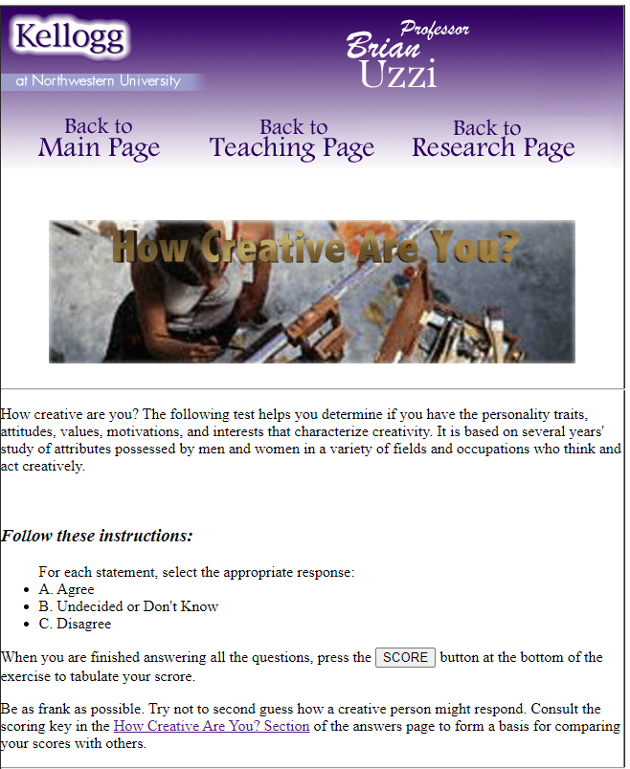

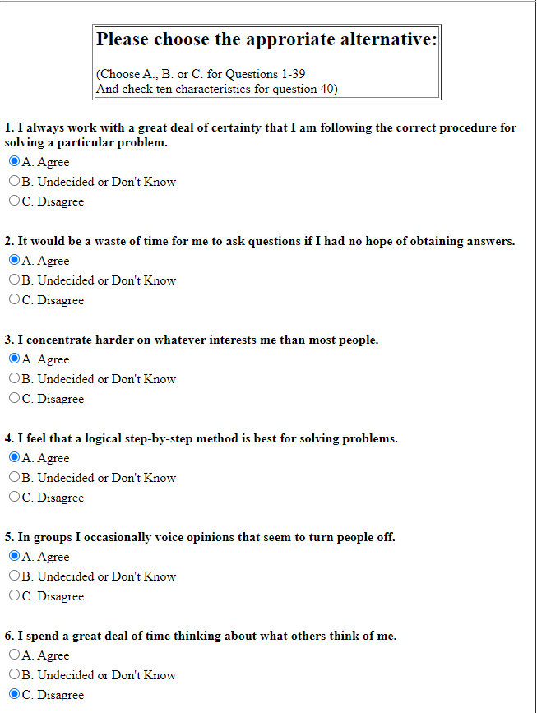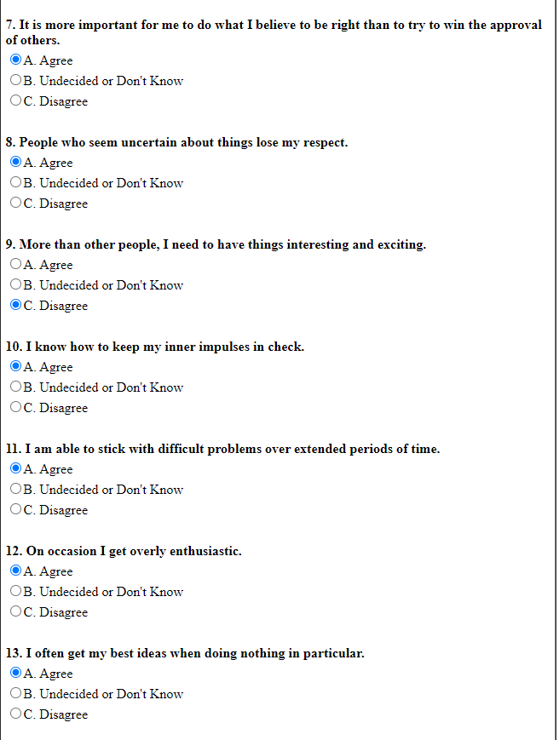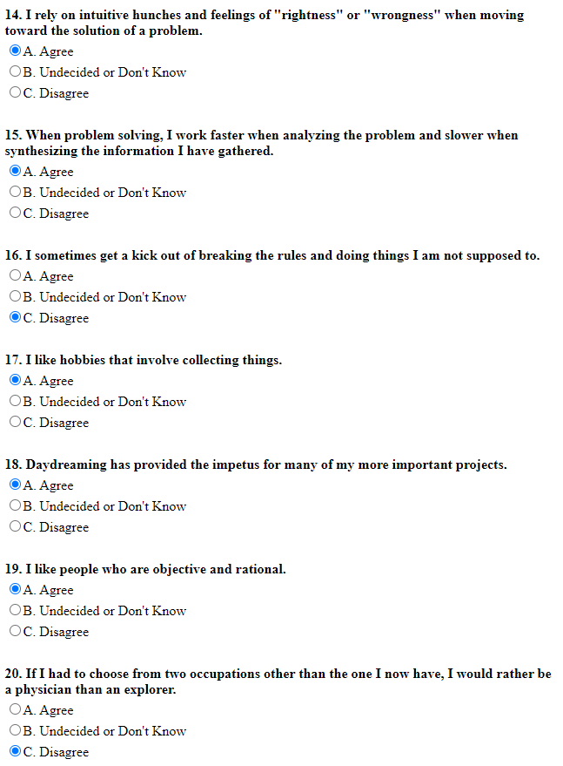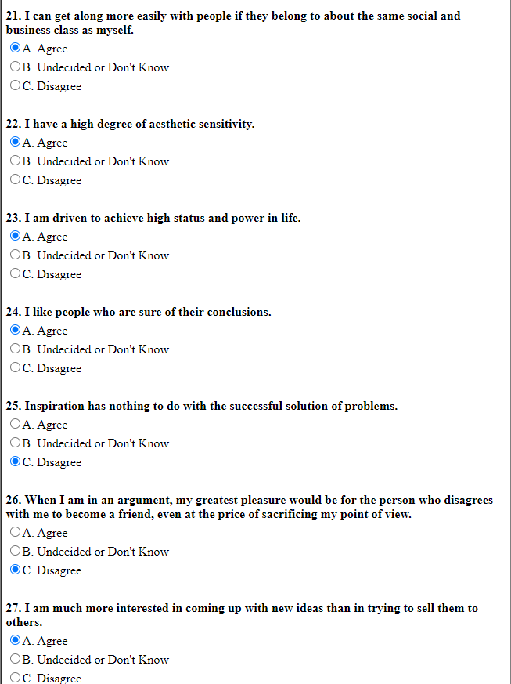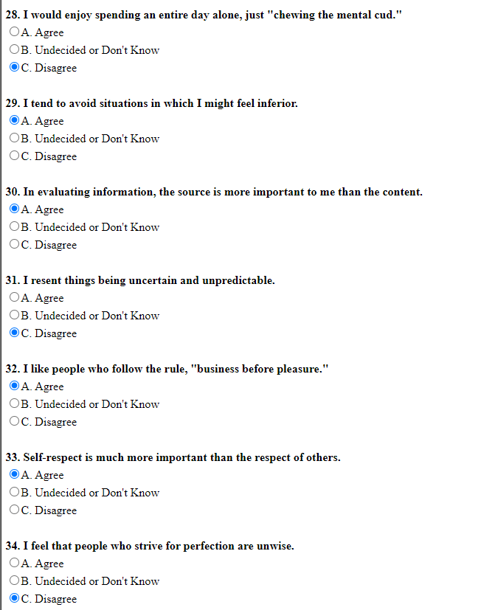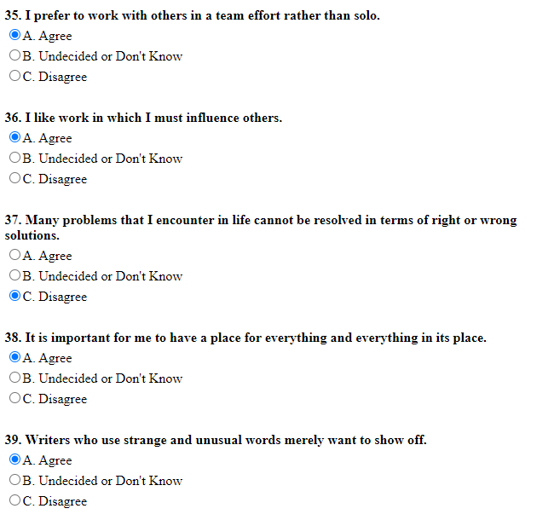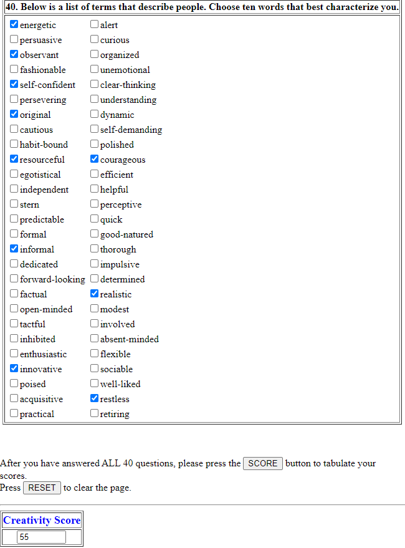

* **TABLE 2:**

**GROUP DISCUSSION**

Based on the findings of this study, we argue that the study of a team’s creative

problem solving ability goes much deeper than personality, cognitive ability, and

the number of ideas a team can generate. Our evaluation of divergent thinking

abilities suggests that creative ability is not just a function of cognitive ability.

Individuals develop creative abilities and teams use these abilities to develop

ideas that can be evaluated by the group. Added to this is the idea that there are

creative personality attributes that may cause some individuals to either be more

creative, or at least feel like they are more creative. This may increase the

individual’s motivation to participate and share their ideas with the team.

However, we realize that this study has limitations based on the sample and the

simplicity of the creative task assigned. Future studies should try to evaluate the

creative process in actual business environments. We believe this study helps

identify the individual attributes that should be evaluated for these studies. It is

almost a certainty that organizations will continue to use groups to solve their

most important problems in the future and this research begins to uncover the

attributes that leaders should consider when they choose the individuals that will

perform on these teams.

When a group of employees is engaged with each other, the potential of the group skyrockets. Your employees will be able to accomplish more, come up with better ideas, and even walk away with higher morale. However, getting the group to[work together in a productive way](http://engageforsuccess.org/how-to-use-motivational-stories-for-better) isn’t always easy.

For example, if you need your team to come up with a creative idea or a creative way to solve an existing problem, an unproductive session could unfold in a number of potential ways:

• Employees may not participate, resulting in more awkward silences than discussion.  
• Employees may over-participate, resulting in a shouting match with no direction.  
• Employees may discuss the problem, but without a vision toward actionable steps.  
• The meeting may take too long, wasting everyone’s time and costing more money than it should.  
• Employees may never land on a final solution.

So how can you foster an environment that inspires productive collaboration??

**Why the Group Approach Is Best**

After reading these potential problems, you may consider whether the group approach to creative problem solving is even worth it. But as [Tim Sykes](http://www.timothysykes.com/2016/10/11-steps-becoming-millionaire/) puts it, “no millionaire is an island.” Nobody can come up with or execute a perfect plan by themselves; they rely on advisors, mentors, editors, and other helpers to shape those plans into something better. Everyone brings something unique to the table, and if you ignore the potential there, you could wind up with a far inferior final plan.

**Strategies for Better Group Problem Solving**

Try using these strategies to facilitate better creative problem solving as a group:

**1. Make someone in charge.** First, identify a “leader” for the meeting, which could be you or another employee. This person may be in charge of a number of responsibilities, such as picking the  meeting attendees, setting the agenda, or leading the discussion, but the most important role is to be the final decision-maker. This will be the person responsible for selecting the final idea and bringing the meeting to a close—which will help stop the endless back-and-forth cycles that some meetings produce.

**2.** **Select the right team.** You’ll also want to take steps to ensure that you pick the right team for the creative brainstorming session. Don’t add people for the sake of adding them—choosing a meeting attendee unfamiliar with the problem will waste your time and theirs. Instead, opt for the most productive candidates for the task, and keep your roster small to encourage more focused discussion.

**3. Mandate participation**. Let your attendees know in advance that you expect them to participate. The purpose of a meeting is to share ideas with one another, and if some people aren’t sharing, that purpose is lost.

**4. Assign homework**. You want every attending employee to be [prepared and with something to offer](http://engageforsuccess.org/how-to-increase-your-value-as-a-potential-employee), so be proactive by assigning homework before the meeting. For example, you could ask them to come up with one potential solution to the problem at hand or ask them to bring some kind of research to the table.

**5. Give people individual time to brainstorm**. You can’t force people to come up with good ideas on the spot. Expecting a group of people to spontaneously come up with a good idea is a recipe for disappointment. Instead, give your meeting attendees time to brainstorm the problem on their own, so they come to the meeting with a handful of solutions already in mind. Some problems will be urgent, but if you can give your attendees a few days to consider the issue, do so.

**6. Keep the meeting short.** Longer meetings may seem like they offer more flexibility to get things done, but in reality, [shorter meetings tend to be more effective](http://www.rmagency.com/the-dreaded-meeting/). Setting a pressing time limit—like 30 minutes or even 15 minutes, forces people to acknowledge the end goal and work toward it as efficiently as possible. If you need to schedule another meeting to explore the idea further, you can, but over the long term, you’ll see faster results and waste less time this way.

**7. Set an agenda.** Before the meeting begins, have your team leader create an agenda for the meeting. This could be simple, such as outlining the order in which your attendees are going to speak, or more detailed, such as offering a breakdown of the problem at hand. Send this out in advance so your employees are more prepared for the meeting, and adhere to it so you make the most of your meeting time and stay on course.

**8. Listen to all ideas.** If you want your employees to voice more of their ideas, [show that you care about all their ideas](https://hbr.org/2016/08/listen-to-your-employees-not-just-your-customers); listen carefully, patiently, and respectfully to every employee idea, and encourage your other employees to do the same. This creates a more comfortable environment, and one that rewards open discussion, so maintain this standard indefinitely. It may take time to kick in, but eventually, your employees will feel more comfortable sharing their true thoughts.

With these strategies, your employees will be able to work together more effectively, with fewer conflicts and with a better chance of landing on an ideal creative solution to the problem at hand. Most of these strategies also become more effective with repetition; your employees will get used to your systems and criteria, and your meetings will flow even smoother in the future, so stay consistent with your approach.

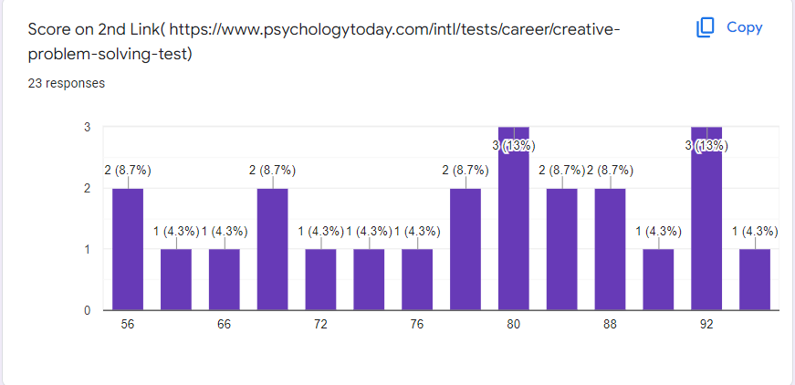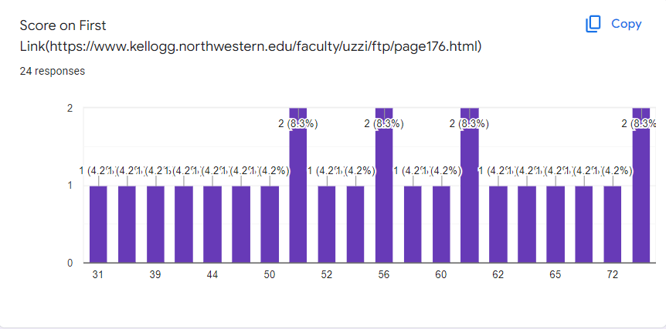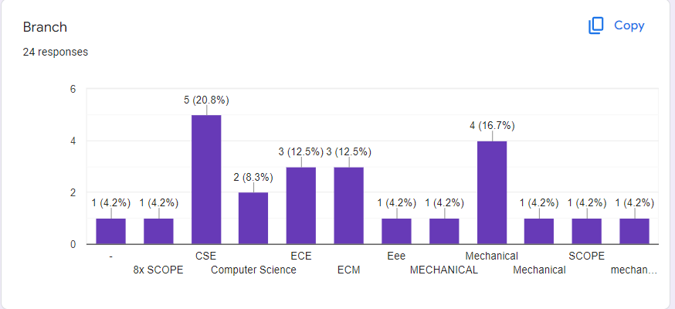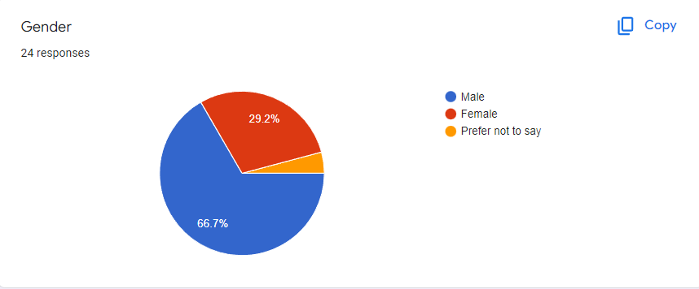

* **CONCLUSION**

**Discussion on problem solving and creativity has been succesfully computed and executed on group and individual levels.**

­­­­­­­­­­­­